ASSIGNMENT 2 solution

Submitted by : Sweta Dhara

1.What are the two values of the Boolean data type? How do you write them?

A: A **boolean** (bool) data type is an essential programming concept. The data type represents two values: **true**or **false**. We have to use capital T and F and with the rest of the word in lowercase. The type() of both False and True is bool. The type bool is built in, in Python.

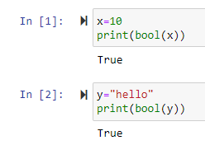

2. What are the three different types of Boolean operators?

A: The three different types of Boolean operators in python are: are, and, not Example: a>40 and b>40

3. Make a list of each Boolean operator’s truth tables (i.e. every possible combination of Boolean

values for the operator and what it evaluate ).

A: The Truth tables for the boolean tables are as follows:

* **Truth Table for and operator**  
  True and True --> True  
  True and False --> False  
  False and True --> False  
  False and False --> False
* **Truth Table for or operator**  
  True or True --> True  
  True or False --> True  
  False or True --> True  
  False or False --> False
* **Truth Table for not operator**  
  True not --> False

False not --> True

4. What are the values of the following expressions?

* (5 > 4) and (3 == 5)
* not (5 > 4)
* (5 > 4) or (3 == 5)
* not ((5 > 4) or (3 == 5))
* (True and True) and (True == False)
* (not False) or (not True)

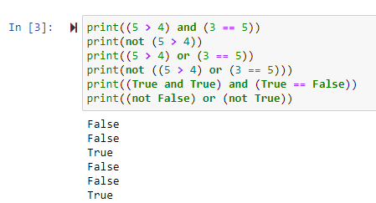

5. What are the six comparison operators?

A: The Six Comparision Operators available in python are: == ,>=,<=, !=,>,<

6. How do you tell the difference between the equal to and assignment operators?Describe a

condition and when you would use one.

A: Equal to(==) operator that compares two values and evaluates to a Boolean, while  =  is that assignment operator that stores a value in a variable. For example, b=10 (assignment operator) &

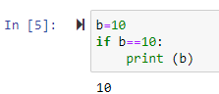

7. Identify the three blocks in this code:

spam = 0

if spam == 10:

print(‘eggs’)

if spam> 5:

print(‘bacon’)

else:

print(‘ham’)

print(‘spam’)

print(‘spam’)

A: ham

spam

spam

8. Write code that prints Hello if 1 is stored in spam, prints Howdy if 2 is stored in spam, and prints

Greetings! if anything else is stored in spam.

A: 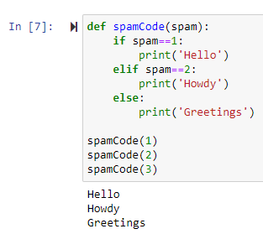

9. If your programme is stuck in an endless loop, what keys you’ll press?

A: To stop a program stuck in an infinite loop, we press Ctrl-c

10. How can you tell the difference between break and continue?

A: The break statement stops the execution outside the loop if break condition is satisfied whereas The continue statement in Python is used to skip the remaining code inside a loop for the current iteration only

11. In a for loop, what is the difference between range(10), range(0, 10), and range(0, 10, 1)?

A: The ***range(10)*** call range from 0 to 9 (but does not include 10).The ***range (0,10)*** explicitly tells the loop to start at 0.The ***range(0,10,1)*** explicitly tells the loop to increase the variable by 1 on each iteration starting from 0.

12. Write a short program that prints the numbers 1 to 10 using a for loop. Then write an equivalent

program that prints the numbers 1 to 10 using a while loop.

A: 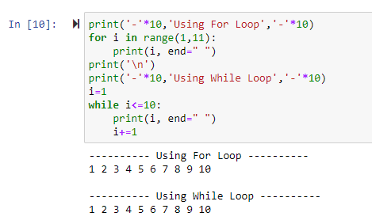

13. If you had a function named bacon() inside a module named spam, how would you call it after

importing spam?

A: The function can be called with spam.bacon()